Name: ID:
Email:
Keystone Algebra 1 Review Module 1
Multiple Choice
Identify the choice that best completes the statement or answers the question.
 | 1. | Which graph represents a linear function?  a. c.  b. d.
 | 2. | What is the slope of the line that passes through the points (-6, 1) and (4, -4)?  a. -2 c.  b. 2 d.
 | 3. | Students in a ninth grade class measured their heights, h, in centimeters. The height of the shortest student was 155 cm, and the height of the tallest student was 190 cm. What inequality represents the range of heights?  a. c. or  b. d. or
 | 4. | The faces of a cube are numbered from 1 to 6. If the cube is tossed once, what is the probability that a prime number or a number divisible by 2 is obtained?  a. c.  b. d.
 | 5. | Which ordered pair is a solution set of the following system of inequalities?  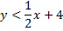  a. c.  b. d.
 | 6. | Which expression is equivalent to ?  a. c.  b. d.
 | 7. | Jack bought 3 slices of cheese pizza and 4 slices of mushroom pizza for a total cost of $12.50. Grace bought 3 slices of cheese pizza and 2 slices of mushroom pizza for a total cost of $8.50. What is the cost of one slice of mushroom pizza?  a. c.  b. d.
 | 8. | What is half of ?  a. c.  b. d.
 | 9. | Which equation represents a line that is parallel to the line ?  a. c.  b. d.
 | 10. | Pam is playing with red and black marbles. The number of red marbles she has is three more than twice the number of black marbles she has. She has 42 marbles in all. How many red marbles does Pam have?  a. 13 c. 29  b. 15 d. 33
 | 11. | What is 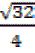expressed in simplest radical form?  a. c.  b. d.
 | 12. | Which equation most closely represents the line of best fit for the scatter plot below?  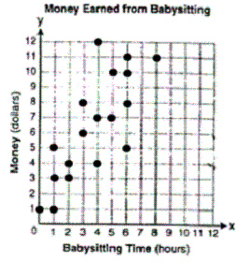  a. c.  b. d.
 | 13. | In a linear equation the independent variable increases at a constant rate while the dependent variable decreases at a constant rate. The slope of this line is  a. Zero c. Positive  b. Negative d. Undefined
 | 14. | Which ordered pair is a solution to the system of equations and  ?  a. c.  b. d.
 | 15. | The gas tank in a car holds a total of 16 gallons of gas. The car travels 75 miles on 4 gallons of gas. If the gas tank is full at the beginning of a trip, which graph represents the rate of change in the amount of gas in the tank?  a. c.  b. d.
 | 16. | If , then x equals  a. c.  b. d.
 | 17. | Nicole’s aerobics class exercises to fast-paced music. If the rate of the music is 120 beats per minute, how many beats would there be in a class that is 0.75 hour long?  a. 90 c. 5,400  b. 160 d. 7,200
 | 18. | The length of the hypotenuse of a right triangle is 34 inches and the length of one of its legs is 16 inches. What is the length, in inches, of the other leg of this right triangle?  a. 16 c. 25  b. 18 d. 30
 | 19. | Which equation represents a line parallel to the x-axis?  a. x = 5 c.  b. y = 10 d.
 | 20. | Sam and Odel have been selling frozen pizzas for a class fundraiser. Sam has sold half as many pizzas as Odel. Together they have sold a total of 126 pizzas. How many pizzas did Sam sell?  a. 21 c. 63  b. 42 d. 84
 | 21. | Which ordered pair is in the solution set of the system of equations and ?  a. (-5, -1) c. (5,-4)  b. (-5,6) d. (5,2)
 | 22. | Which statement is true about the data set 3, 4, 5, 6, 7, 7, 10?  a. Mean = Mode c. Mean = Median  b. Mean > Mode d. Mean < Median
 | 23. | Which value of x is in the solution set of the inequality ?  a. -2 c. 3  b. 2 d. -4
 | 24. | Don placed a ladder against the side of his house as shown in the diagram below.  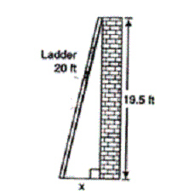  Which equation could be used to find the distance, x, from the foot of the ladder to the base of the house?  a. c.  b. d.
 | 25. | Which value of x is a solution of  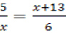?  a. -2 c. -10  b. -3 d. -15

